Heart of ruin inventory system breakdown
  - Its not as scary as it looks…..well that’s subjective

System overview
This inventory system is relatively simple in concept, but the code can be quite hard to follow. I have simplified things down as much as possible while retaining robustness and integrity to attempt to prevent common exploits or rectify the system if an exploit is executed.
NOTE: Object = something we can see in the scene tree (on the left in grey), Component = different sections that can be seen in the inspector when and object is selected (usually on the right side of the Unity Editor)
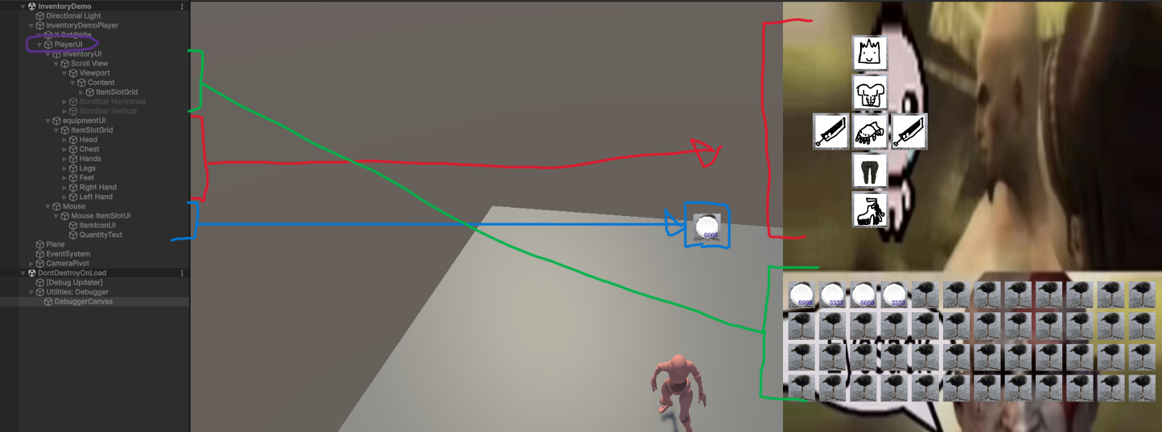
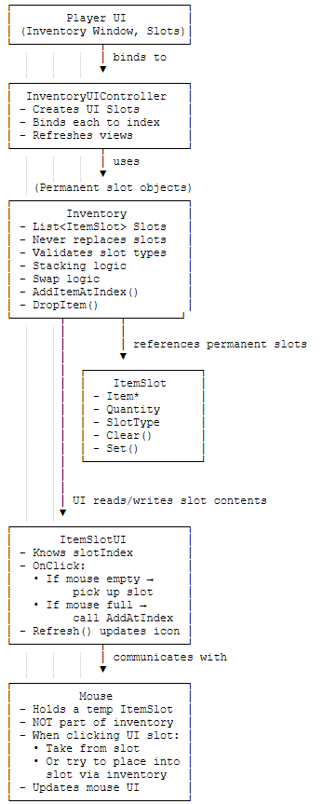
You may need to zoom in a bit to see clearly but here is how the UI Is structured in the scene graph. All three major UI components (inventory, equipment inventory and mouse) are attached to the PlayerUI object. The actual inventories are on the player (“InventoryDemoPlayer” in this scene). There are two inventories, one for the equipment and one for general storage, this was done to have the same functionality on both classes.
In code the system operates following the workflow seen in the image to the left. This diagram shows how a single inventory is handled. Additional inventories simply slot into the working system but require their own Inventory UI controller.

UI Layout
I will outline the basic setup of how the individual components of the inventory UI system.

Inventory UI
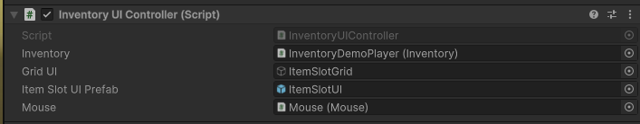
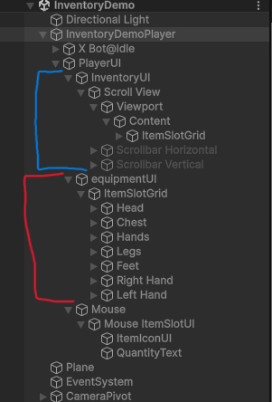
This is the core component of the inventory, As you can see in the image to the right we have two separate inventories setup in the demo scene. Each with different layouts but the core components are the same.
Highlighted in blue we have the core player inventory; this will be the standard structure for any inventory since it will automatically scale. There are two primary things we need to pay attention to here, the “inventoryUI” object and the “ItemSlotGrid” object, these are the two most things required to operate the inventory.

The inventoryUI object has the Inventory UI controller component, this can be found in the inspector with the inventoryUI object selected.
This is the main driver of the UI. It has 4 fields that need to be filled in to work:
- Inventory: this is a reference to the inventory component that is to be displayed.
- Grid UI: this is a reference to the other core part of the inventory UI and tells the UI which object is to be the parent that will “adopt” the item slot UI elements when they are created.
- Item Slot UI Prefab: this is the prefab used to display the item which will be covered in another section
- Mouse: this is a reference to the Mouse component that is found on the Mouse UI object. This will be explained later in the Mouse section. This is technically optional, but the UI will be non-interactable without a reference to a mouse component.
We then also have the ItemSlotGrid object, as stated in the previous paragraph, this component tells the inventory where to place the item slot UI elements.
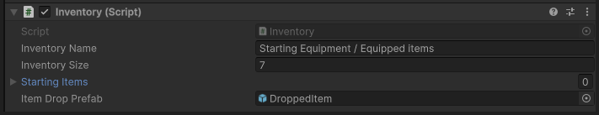
Highlighted in red is the equipment inventory, this is as basic as it can really get, equipmentUI has an inventory UI controller and itemSlotGrid houses the item slot UI elements. This one operates the same but with a key difference in setup, the slots are pre-placed onto the itemSlotGrid, and the number of slots matches the number of item slots on the given inventory: 7 inventory size, 7 predefined item slots. Internally in the InventoryUIController, it checks for slots already In the UI and only ever creates new slots if there aren’t enough already, therefore for small inventories like the equipment we can pre-place them and position them as we see fit.

Item slot UI
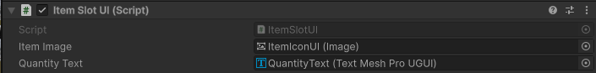
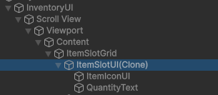
This inventory element is relatively simple; there is a prefab for them saved. Check the Inventory UI section to understand better how these are used, but the key things to note are, the ItemSlotUI object has the background image of the slot, in the demo scene this is the picture of the One footed bird. The ItemIconUI is the picture of the actual item held in the item slot, and the quantityText is the text to display the quantity of the item in the slot. It will not display the quantity if it is 0 or 1. NOTE: currently there is no visual display for which TYPE of item slot is displayed (head, chest, etc..) THIS WILL BE ADDED IN THE FUTURE.

Mouse UI
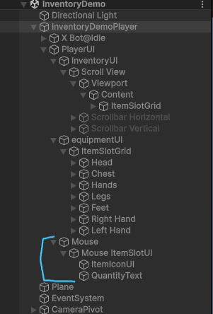
This component allows the user to move items around between slots across any inventory. In effect it functions like a floating item slot. When the user clicks an ItemSlotUI, it passes that item to the mouse, the mouse can then place that item in different slots in any inventory currently displayed on screen.
The “mouse” UI element houses the cursor image used for the mouse, this is something we need to discuss if we want or not but I added it just in case. Then beyond that, it just has its own ItemSlotUI which functions like any other but displays the mouse’s held item.
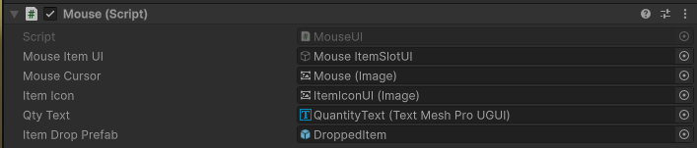
The mouse object has a mouse component with several references

- Mouse item UI: reference to the ItemSlotUI object of the mouse
- Mouse Cursor: the image used to display the cursor.
- Item icon: item icon image on the ItemSlotUI of the mouse.
- Qty (quantity) Text: The quantity text on the ItemSlotUI of the mouse.
- Item Drop Prefab: This is the prefab object that will be used to show the world representation of an item when it is dropped from the mouse. As a fallback it will use the Item Drop Prefab from the inventory it last picked an item up from if the field is left empty.

The code stuff…

This is a large system, and some code currently is in place without anything that uses them yet. These are things like quick transfer for items from one inventory to another or transferring entire inventories between each other.
I’m going to place this diagram here again for reference. This is the cleanest overview possible for how the system works.

Items
Items are what go into the inventory and are managed by the system. Here is how the inheritance flows:
- Item: Base class for all items and contains all the basic information needed for an item including max stack size, name, description, UI icon, etc.
  - EquippableItem: These are items that have additional effects, these have stat bonuses applied when equipped and itemEffects
    - Weapon: Has Damage Scalings (used for the combat system) and a weapon type (currently no functionality)
    - Armour: Just an equippableItem with no additional data or functionality.
Currently there isn’t much else to cover about them, they can be moved around inventories, dropped, stacked, etc.

Item Slot
These are objects that house items, they control a lot of the item validation to prevent glitched items from occurring and remaining in the game should they occur anyway. They primarily check for quantity and item type to ensure that the right items go into the right slot and items can’t go into places they shouldn’t.
If modifying the system at all, remember that ItemSlots aren’t to be replaced unless necessary, they are only to be mutated. The system uses references to item slots for almost EVERYTHING. This means that if a reference is nullified without proper care, things will break.

Inventory
This is the big one, a glorified list of item slots. Handles the main functionality for adding and removing items, spreading items across slots based on quantity, swapping slots in the inventory and also handles size changes for the inventory to allow for dynamic sizing (should we need it).
It functions as you’d expect effectively mimicking inventory systems like Minecraft:
- Item added at specific index: fills stacks of matching items, returns whatever is left to sender.
- Item added at non specific index: fills stacks of matching items, fills in next available empty slot.
- Item removed: tell player to remove stat bonuses
- Inventory size increased: add slots to the back
- Inventory size decreased: remove empty slots first to, then remove filled slots from the back and drop the items to the world
Theres a lot more I could go into, but it would just be much easier to talk to me about it.

Item Pickup
This is the component used for the dropped items; they handle putting the item into inventories when collided with. Use to create dropped Item prefabs.

Item effects
This class contains various methods that can be overridden to define specific item effects. Some Effects will require implementation in multiple methods depending on their nature. Some Effects may also require additional variables to track state. Example: A counter for number of attacks since effect last triggered, or a Timer for timed effects.
Currently the only effect bound to anything by default is the on equip effect. The rest will be implemented later down the line.

